Task -4 Firewall Configuration Task – UFW on Linux

Step 1:

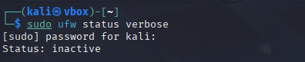

This command checks whether the firewall is currently active and lists the rules configured. At this stage, we check the current state before making any changes.

Step 2:

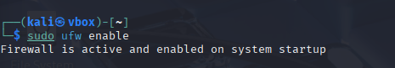

Enables the UFW firewall.

Step 3:

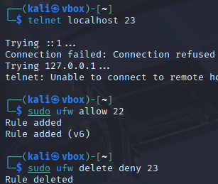

This test checks if the block is working by trying to connect to port 23. You should receive a "Connection refused" or similar message.

SSH is essential for remote system management. This rule ensures that SSH connections (port 22) are allowed, preventing accidental lockout.

After confirming the block rule worked, this command removes it to restore the system to its original state.